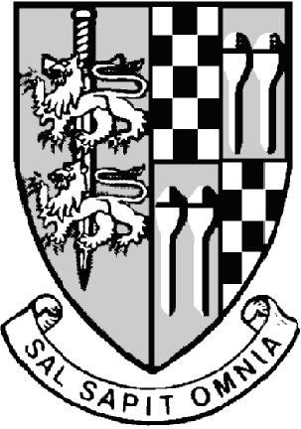Droitwich Spa Town Council

6th March 2023

Town of Wich

Otherwise

Droitwich

ST RICHARD’S HOUSE

VICTORIA SQUARE

DROITWICH SPA

WORCESTERSHIRE, WR9 8DS

TELEPHONE: 01905 774258

FACSIMILE: 01905 794226

[www.droitwichspa.gov.uk](http://www.droitwichspa.gov.uk)

[www.visitdroitwichspa.com](http://www.visitdroitwichspa.com)

**Mr Mark Keld**

TOWN CLERK

mark.keld@droitwichspa.gov.uk

**Local Government Act 1972 Schedule 12 - Part 3**

# **Droitwich Spa Town Meeting**

Notice is hereby given that the Annual Town Meeting for the town of Droitwich Spa will be held in the Main Hall, Droitwich Spa Community Hall, Heritage Way, Droitwich Spa on **Monday 13 March 2023 at 6.30 p.m.**

## A G E N D A

1. To confirm the Minutes of the last Town Meeting held on 9 May 2022.
2. To receive the reports of the Town Mayor and the Chairmen of the Council’s Standing Committees.
3. To receive items to be referred to the Town Council by members of the public.
4. Communications as permitted by the Mayor.



Mark Keld

Town Clerk

Droitwich Spa Town Council

6th March 2023